**May 11 – May 22**

**Assignment: *Artwork Reenactment***

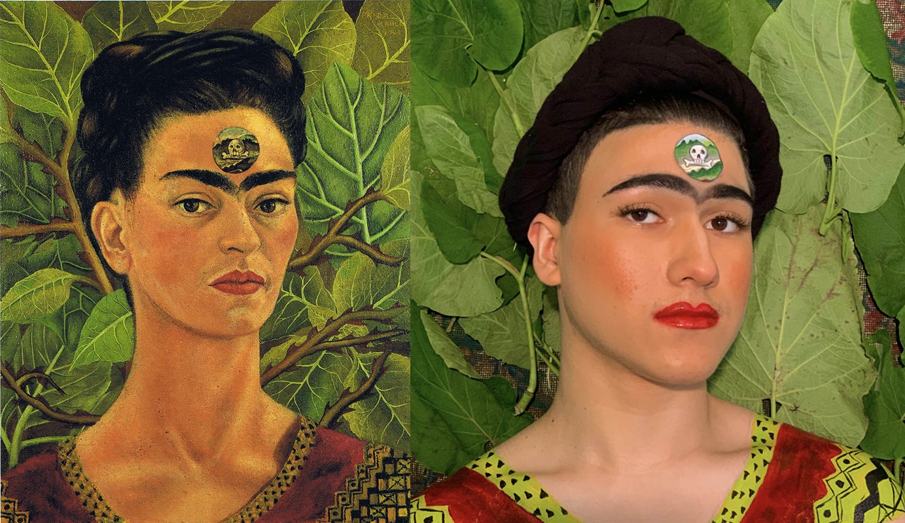

This week I have a bit of a tricky assignment for you. You are going to *recreate a famous artwork!*

**BE MINDFUL about your artwork choice***.* What items do you have around the house that you can use?

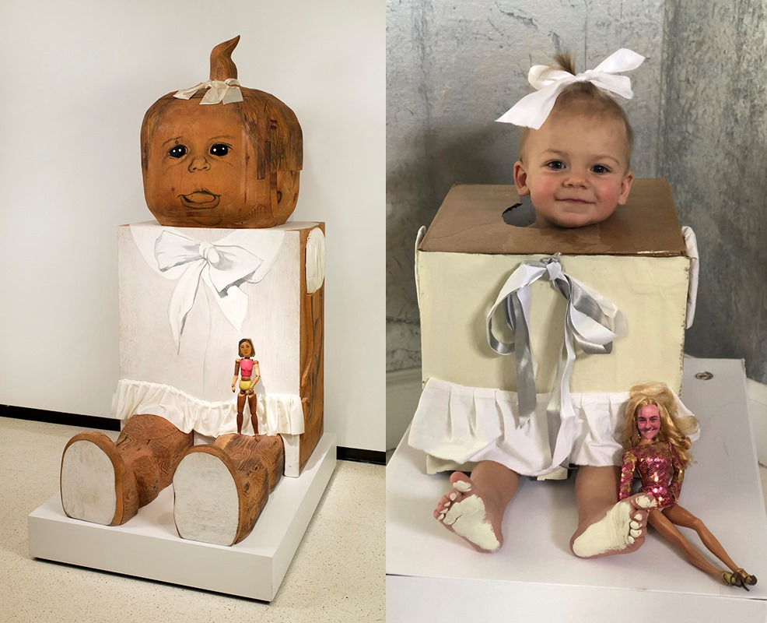

**Supplies you’ll need:**

* **MODEL** – *does your artwork show people? How many models will you need?*
* **FOUND OBJECTS** – *anything you find around the house that may help your artwork reenactment including clothing and props*
* **PHONE –** *to take a photo!*

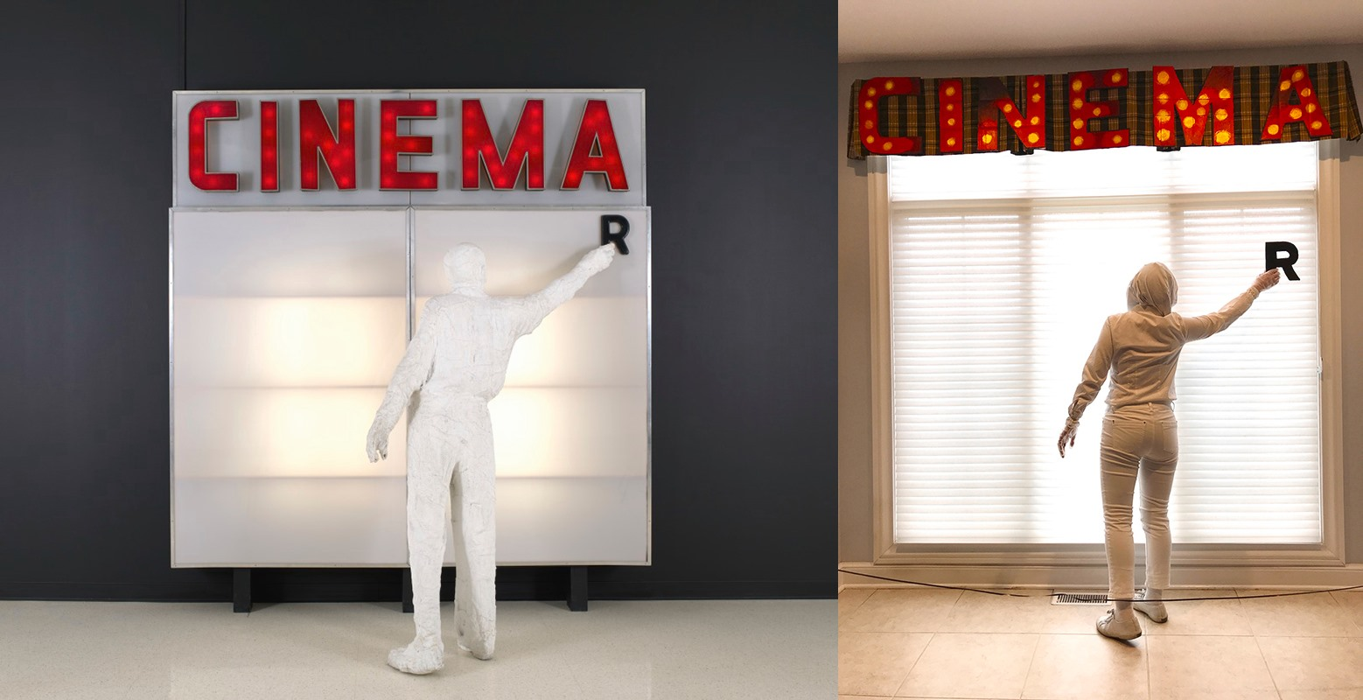**REQUIREMENTS:**

* You will recreate a famous artwork of your choice.
* It should be evident that this took a significant amount of time.
* Reflection – You need to answer the reflection questions and send along with your photo.

*NOTE:* Failure to meet these requirements will result in points taken off.

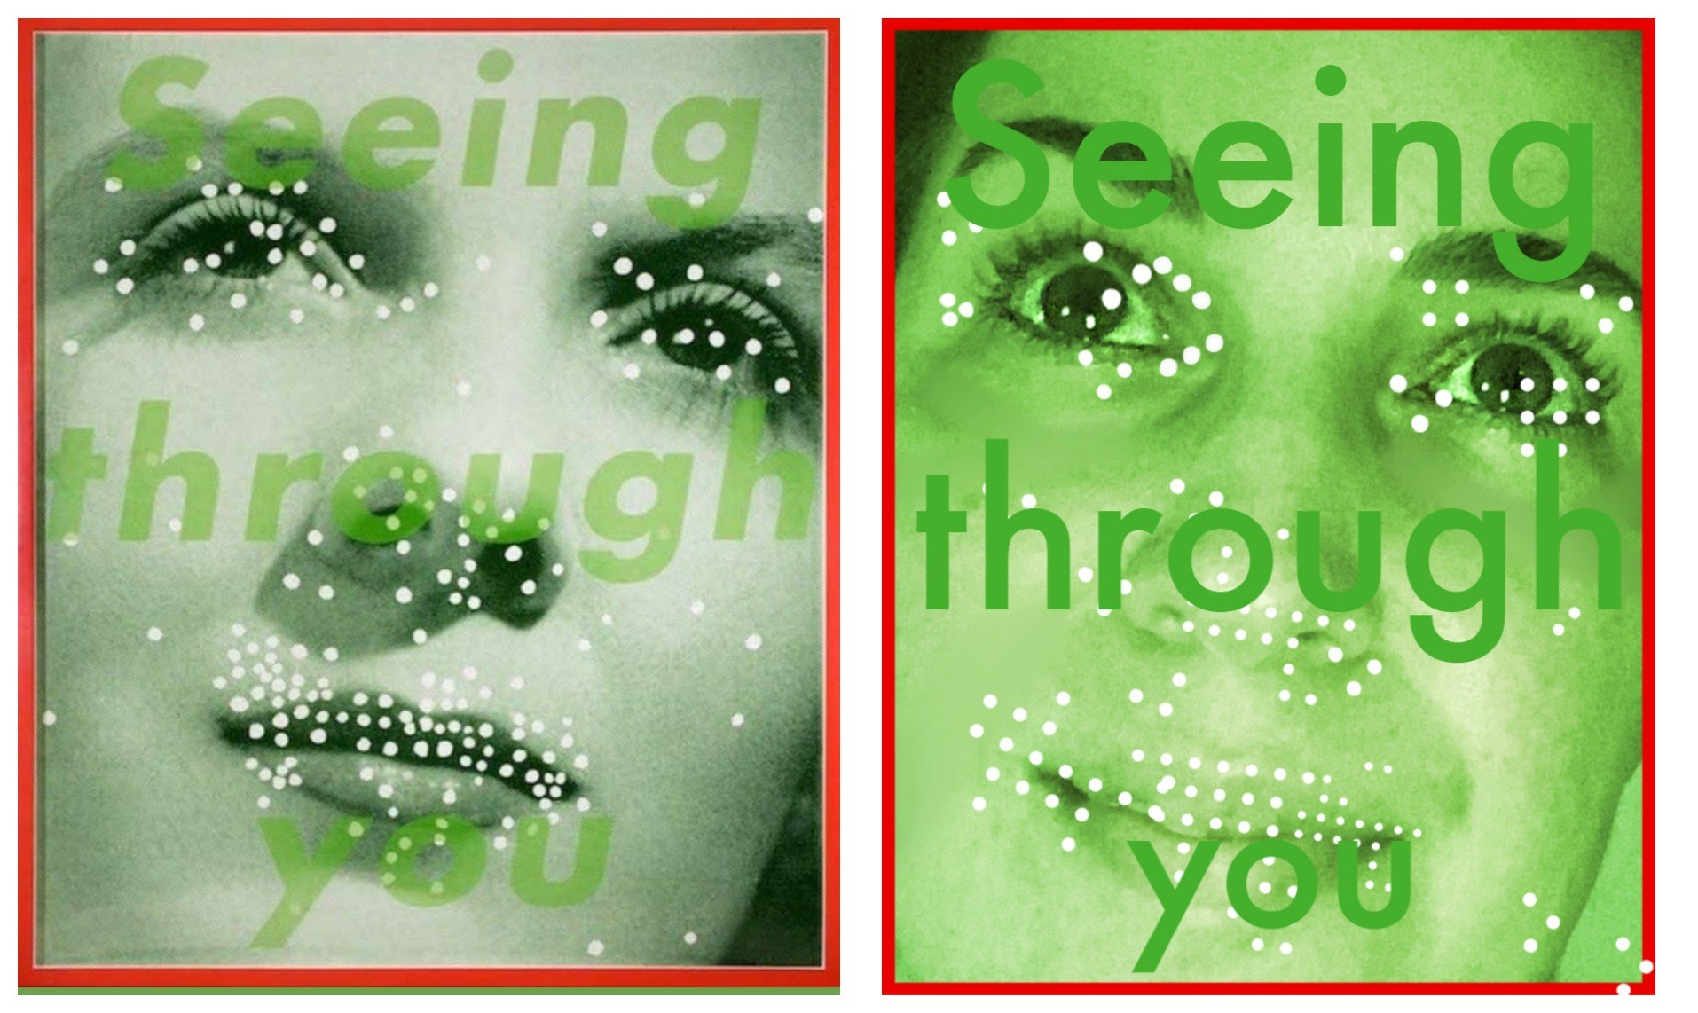

**VOCABULARY** –

*Reenactment -* the acting out of a past event.

**Part 1: Choose your artwork & Gather your materials**

You will choose a work of art to re-create at home. You can choose *any* work of art that you think that you can re-create at home.

**When you are looking through works of art to recreate here are some things to think about:**

**Clothing and fabric:** What are the people in the art work wearing? Can you create something *Similar?*  It does not need to be exactly like the original.

**Props:** What props or materials will you need? Using current events (for example: COVID-19, or face masks) is a fun way to make your piece more modern.

**People:** You can use yourself as a model. You can use members of your family. Pets? Include them if you want!

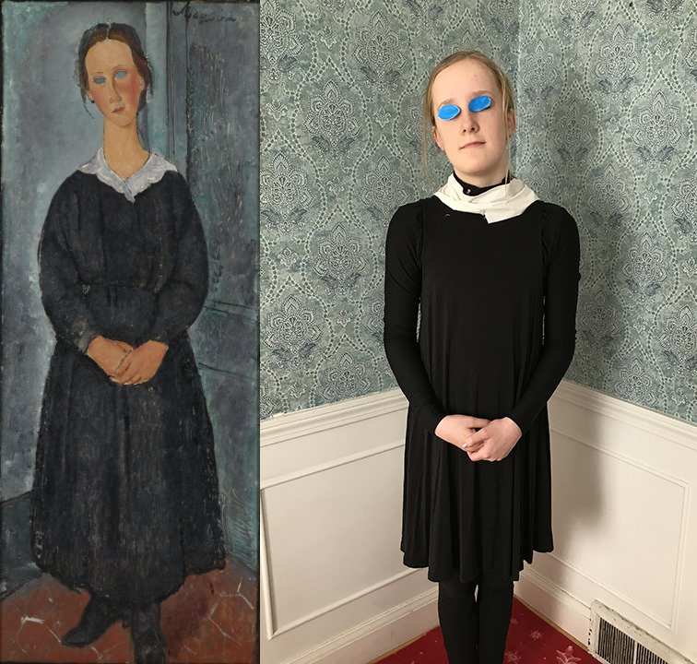

**Part 2: CREATE YOUR ARTWORK**

* Set up your area & Play around with positioning of items.
* **Background** - Try to match the original artwork to the best of your abilities. Be careful what is in your background! Make sure the you do not have items that should not be there.
* **Take multiple photos! You don’t always get the right one on the first try!**

**Part 3:** **REFLECT** – *Answer the following questions in paragraph or bullet.*

* What is the name and artist of the artwork you choose to recreate?
* Why did you choose the materials you did?
* What do you like about your final artwork? Did you surprise yourself?
* Tell me about your process for recreating this artwork.

**SUBMIT WORK -** *Please send a picture of your artwork AND your reflection.*

How can you send your work? 1 of 3 ways.

1. Send through Office 365 TEAMS (each of you have an account and are already added to your class TEAM)
2. Send through the Remind app
3. Email to me at [cswiatek@nfschools.net](mailto:cswiatek@nfschools.net)

**DUE FRIDAY MAY 22nd**

Check out some of the examples below for ideas!

Please contact me if you need help.

**Examples:**

***All of the examples shown were submitted to the Albright Knox’s VIRTUAL ART ALIVE 2020.

I found these images on the Albright Knox Facebook Page. There are almost 300 submissions on their page, feel free to check them out for more ideas!

<https://www.facebook.com/pg/albrightknoxartgallery/photos/?tab=album&album_id=10156819004742163&ref=page_internal>